**BACKUPS**

**TO START   
 1.) Menu  
 2.) Maintenance  
 3.) Backup**

Backup

33 1*1*

Maintenance

2 1*1*

Menu

1 1*1*

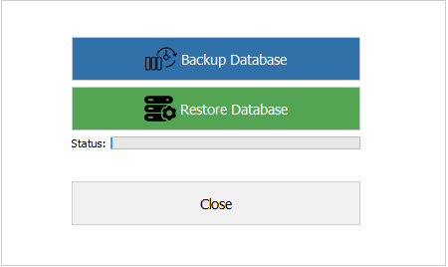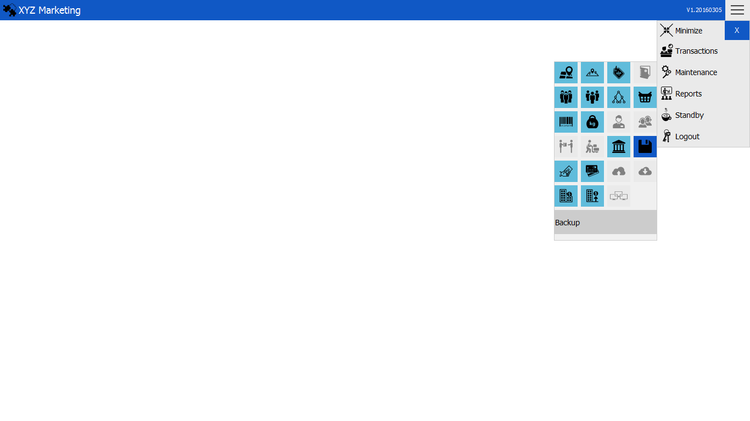

Choose action.  
a.) Backup Database  
b.) Restore Database  
The process will take time and progress will show in the status bar.

Status progress bar

Restore Database

Backup Database

After clicking the backup icon, this box will pop up.

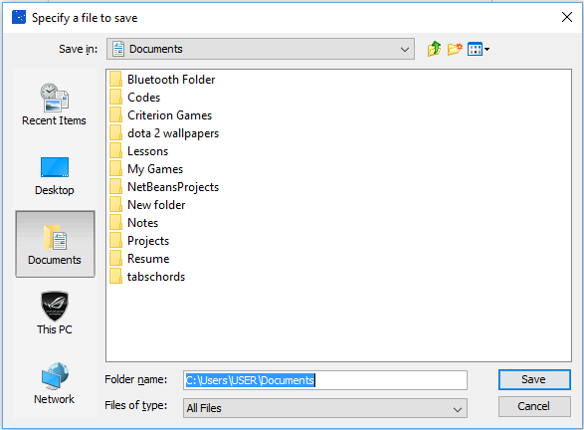**1.) Backup Database**

Choose specific folder where you will save the backup database.

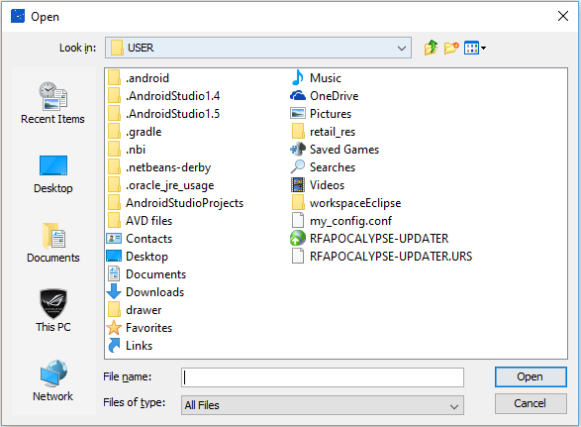**2.) Restore Database**

Open the folder containing the backup database to restore.